Week: 1
“Lab Safety Worksheet”
Total Marks (20 Marks):
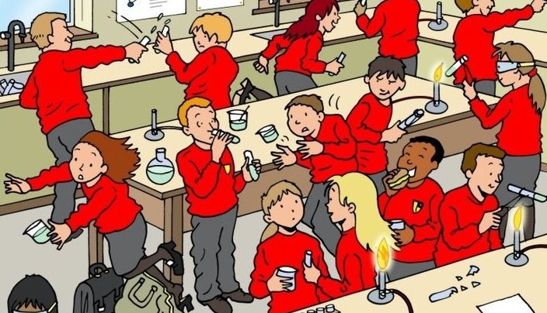
1) List five ways in which lab safety is not being followed, based on the picture provided below (5 marks).

Spot the safety Hazards:-
- The girl is tripping over because of the bag, along with the acid in her hands.
- One student is eating in the lab. Eating and Drinking should be done outside of lab.
- Two kids are playing with the test tubes in their hands and throwing acids on each other.
- One girl is running in the lab. That should not be done
- There is a broken test tube on lab table.

2) Read the statement below and write whether it’s true or false in the box. (5 marks)
- All accidents and injuries in the science lab should be handled by the students themselves.
- The correct way to combine acid & water is to add acid to the water.
- Long hair (not tied back), dangling jewelry, and loose clothing are cool in science labs.
- It is ok to point the open end of a test tube being heated at yourself or someone else.
- If you spill an acid or a base on yourself, you should rinse with a neutralizing solution
Number | True/False
1 | F
2 | T
3 | F
4 | F
5 | F

3) Insert images of five laboratory instruments observed in the lab. (5 Marks)
1: 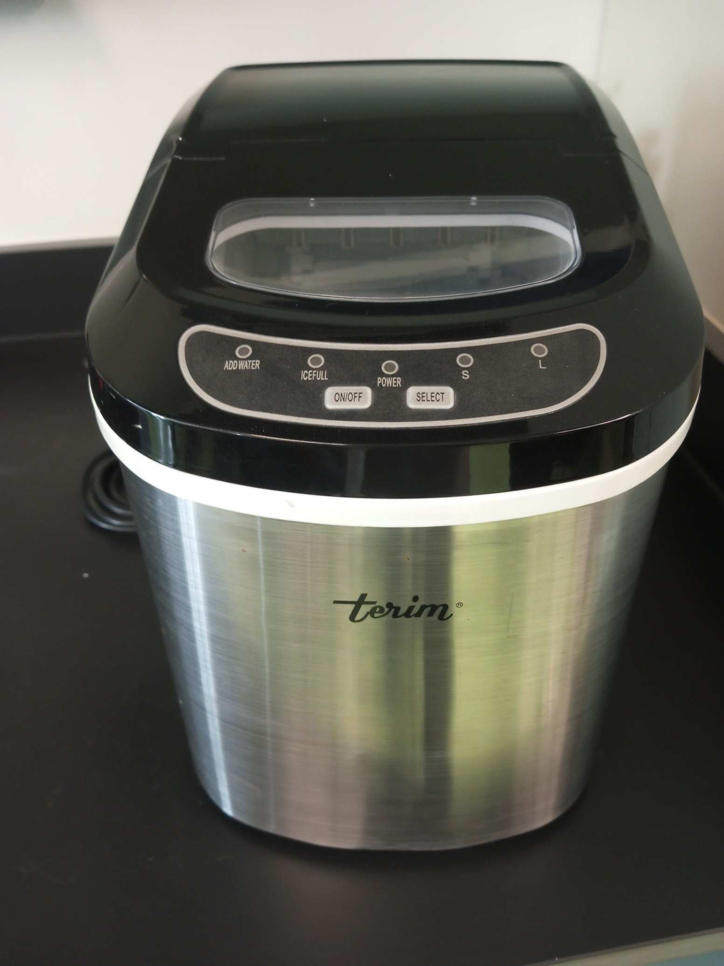
2: 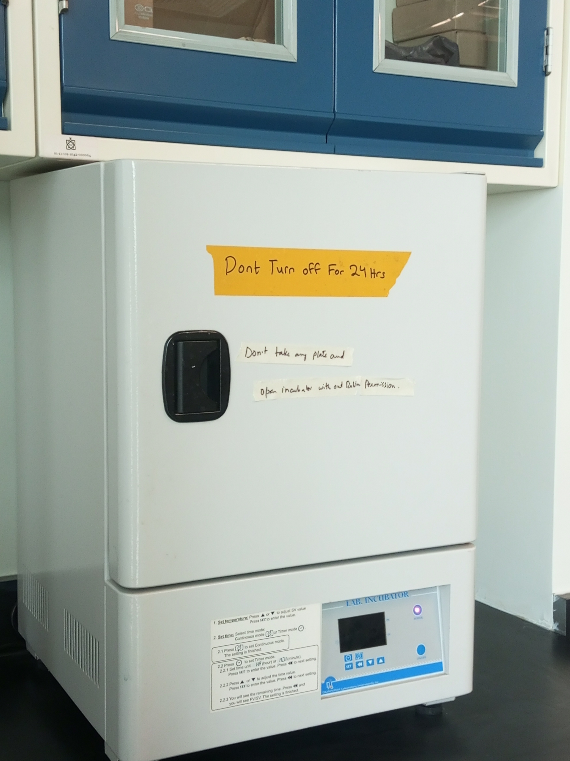

3: 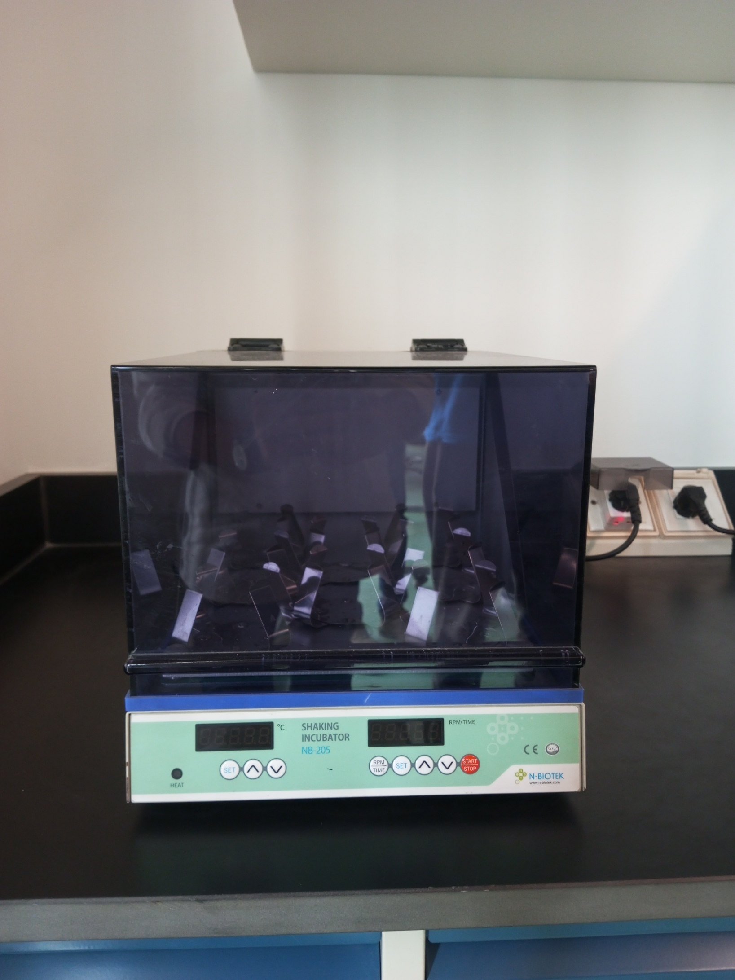
4: 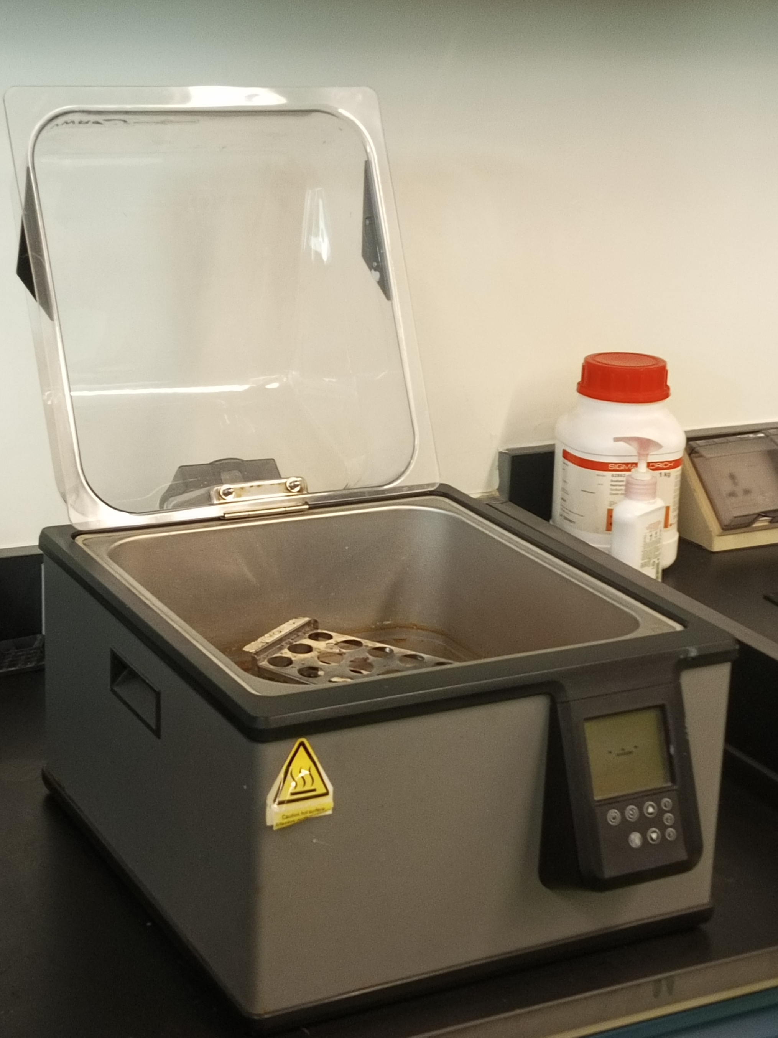
5: 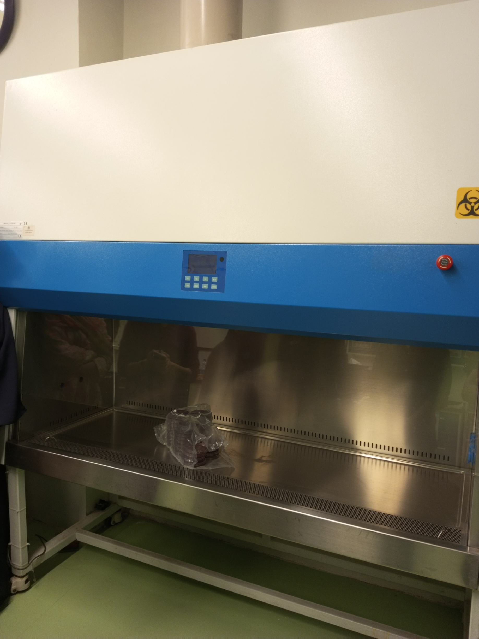

4) Insert images of any ten-laboratory apparatus observed in the lab. (5 Marks)
1: 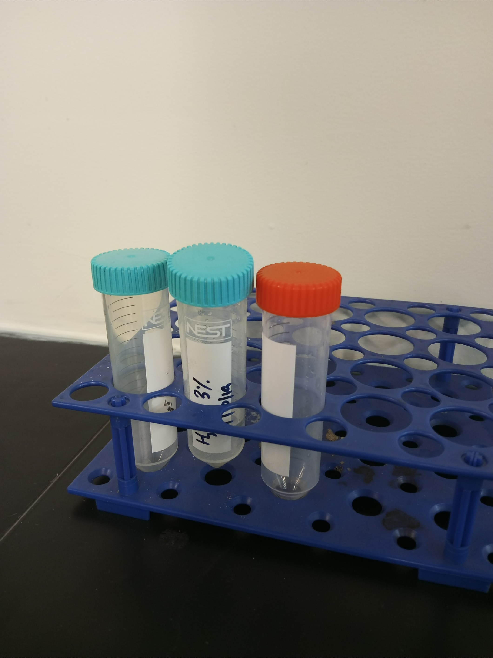
2: 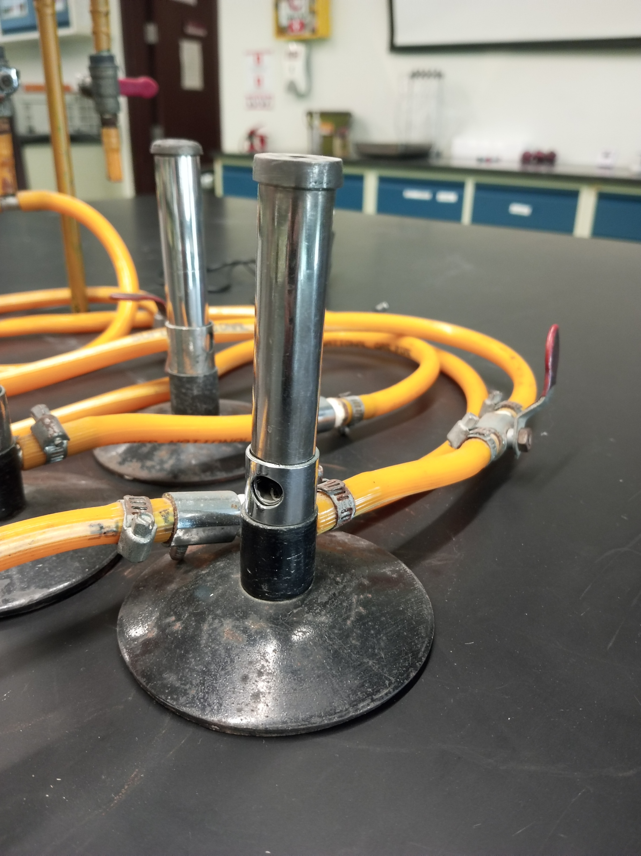
3: hh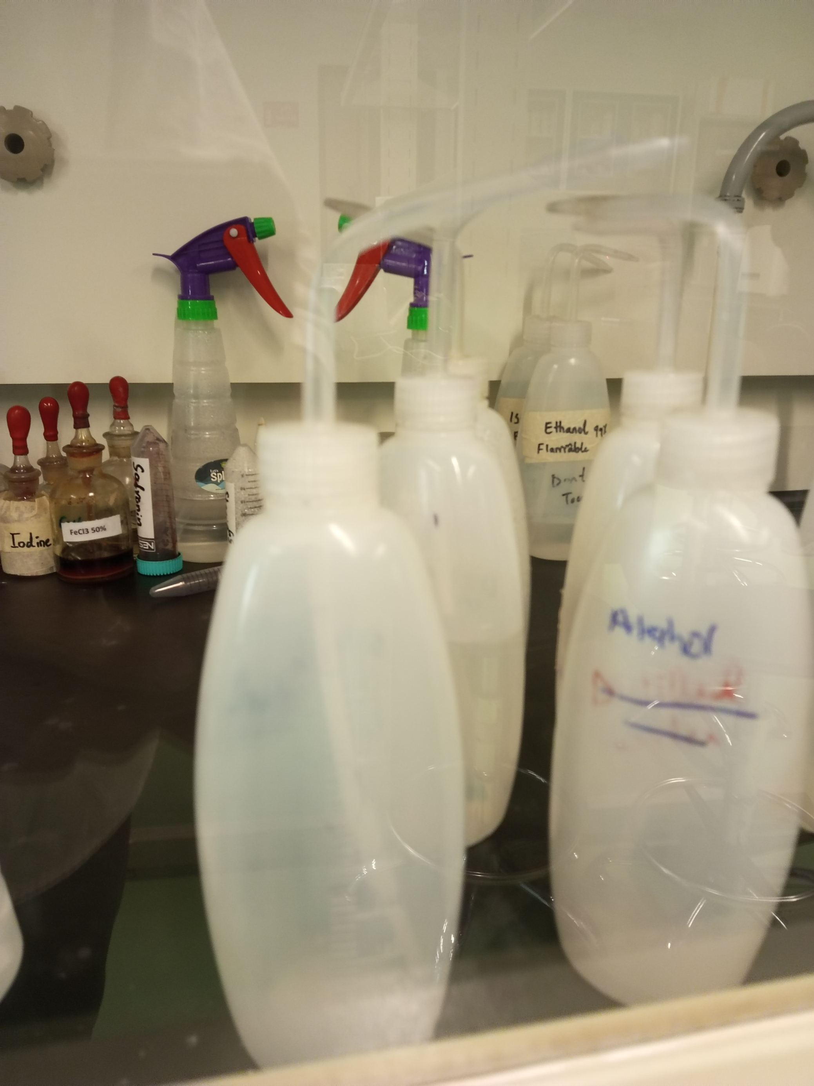

4&5:
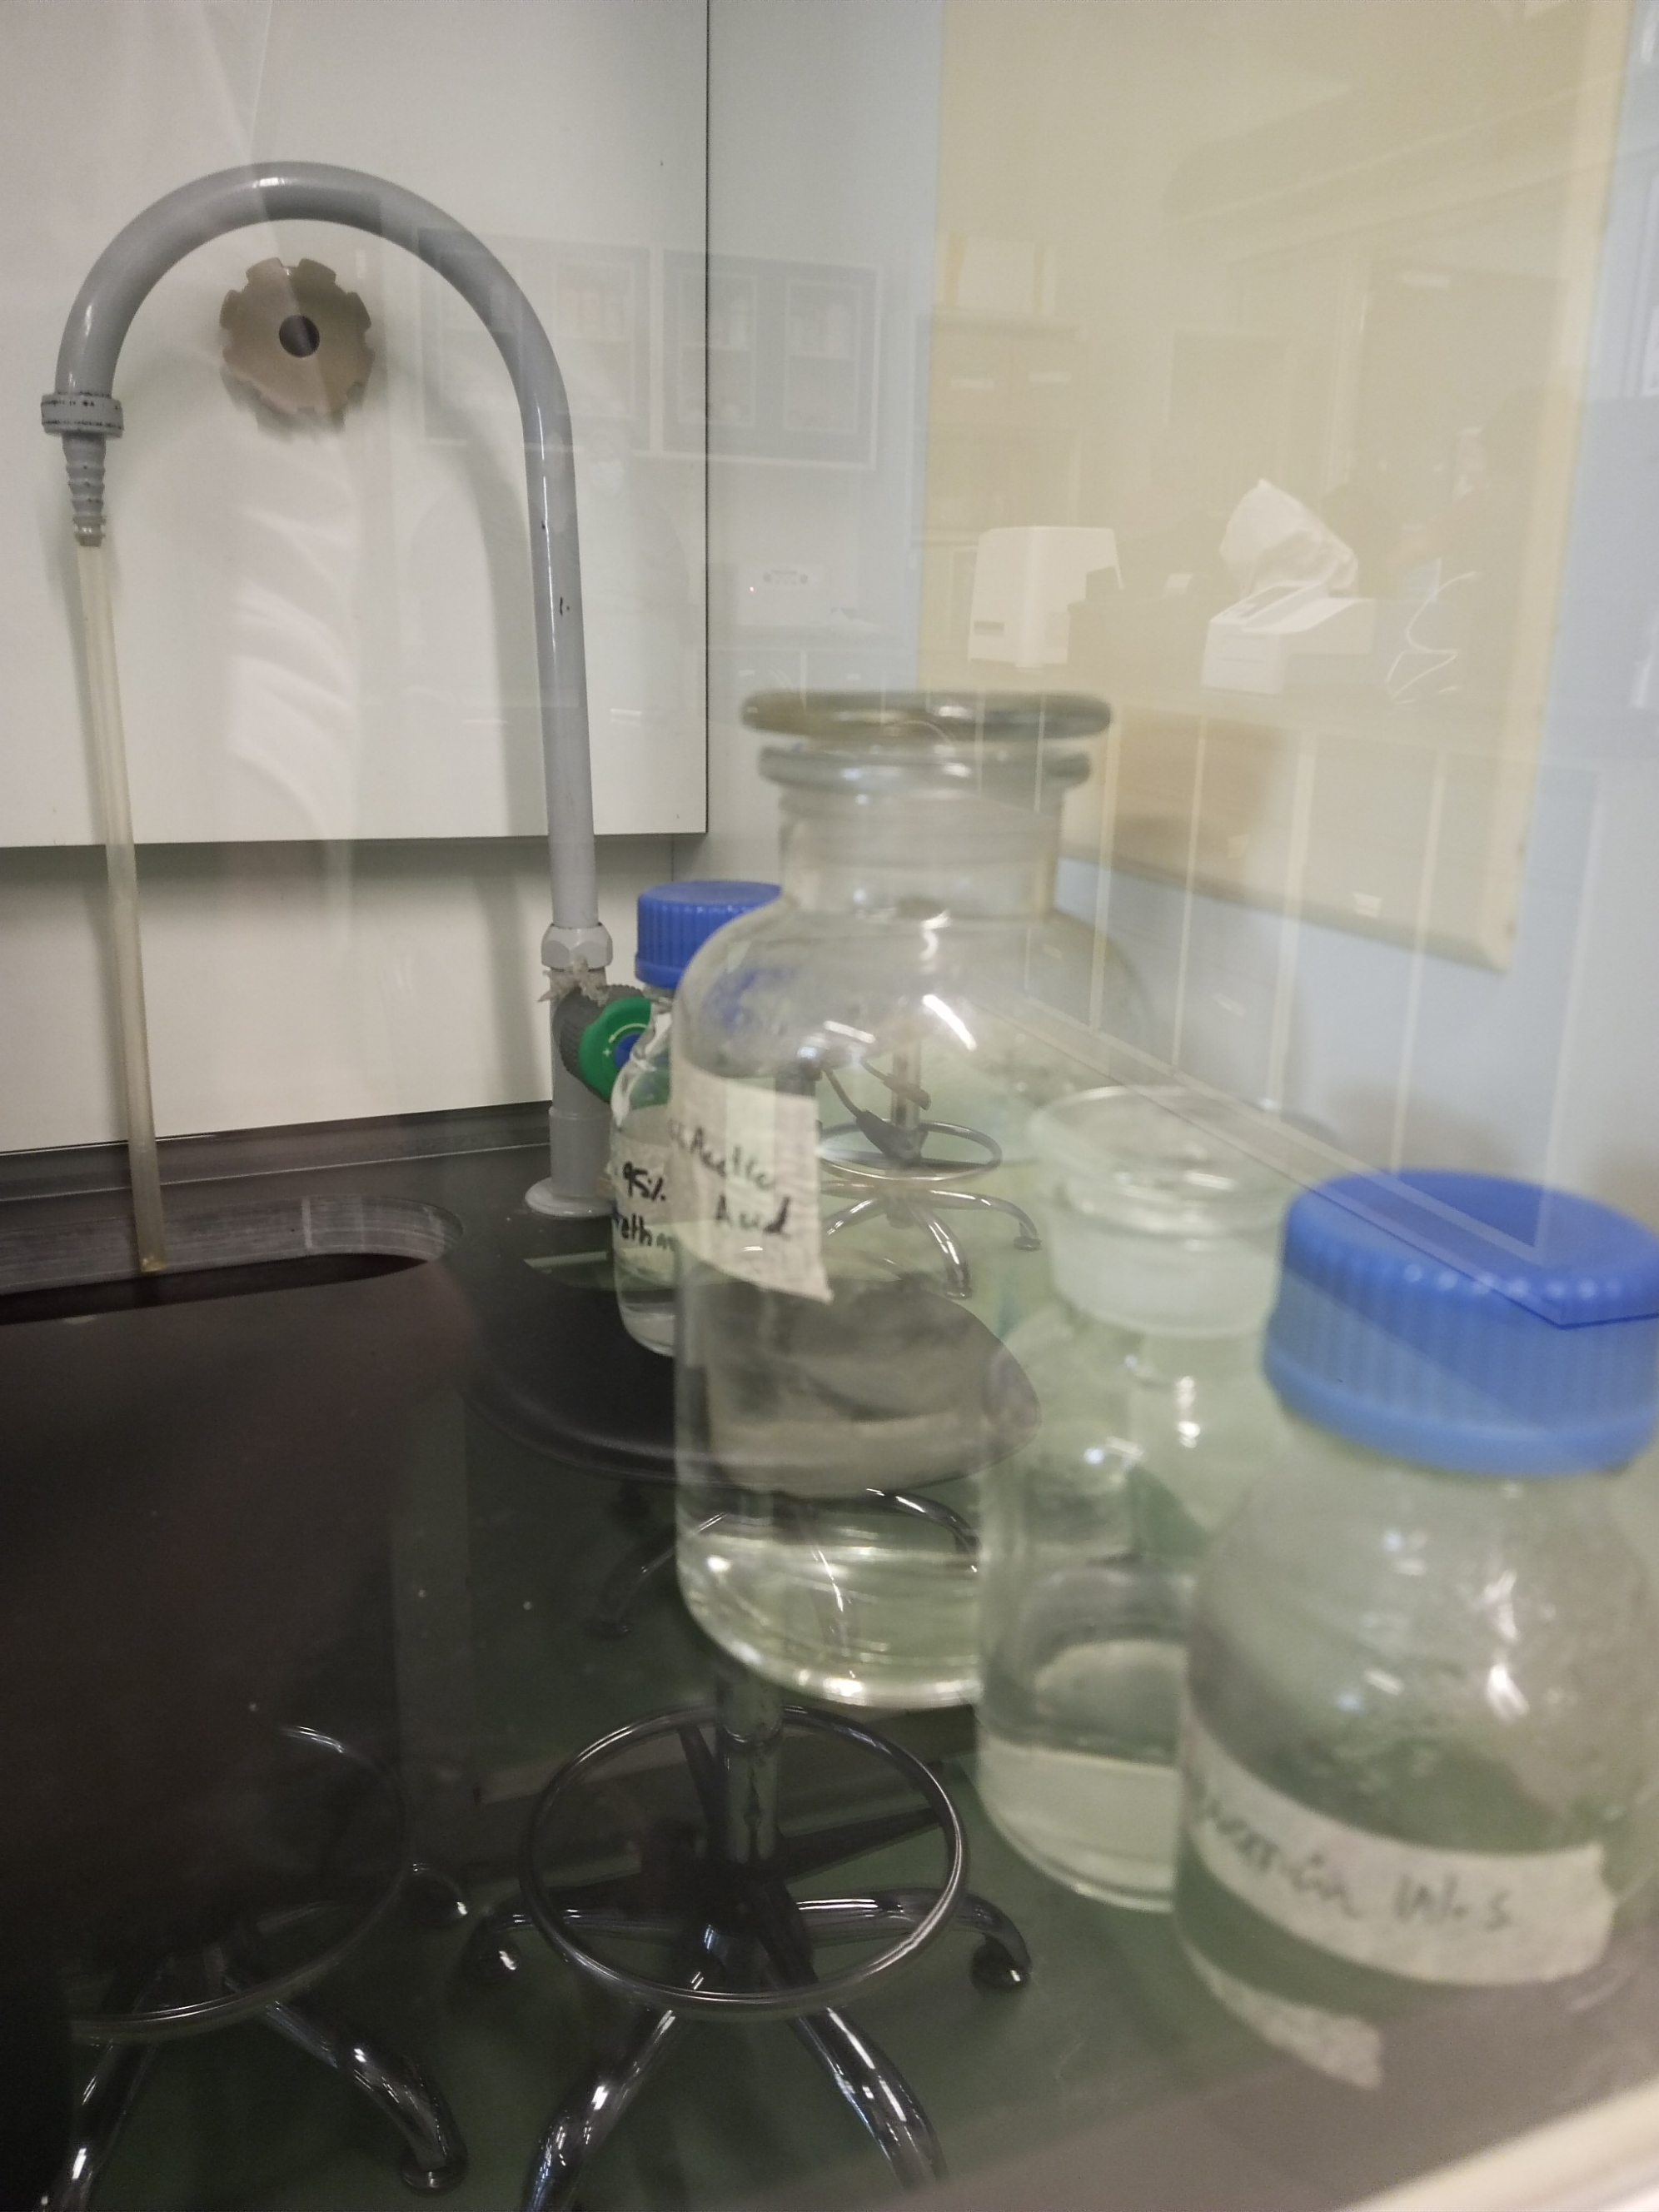

6: 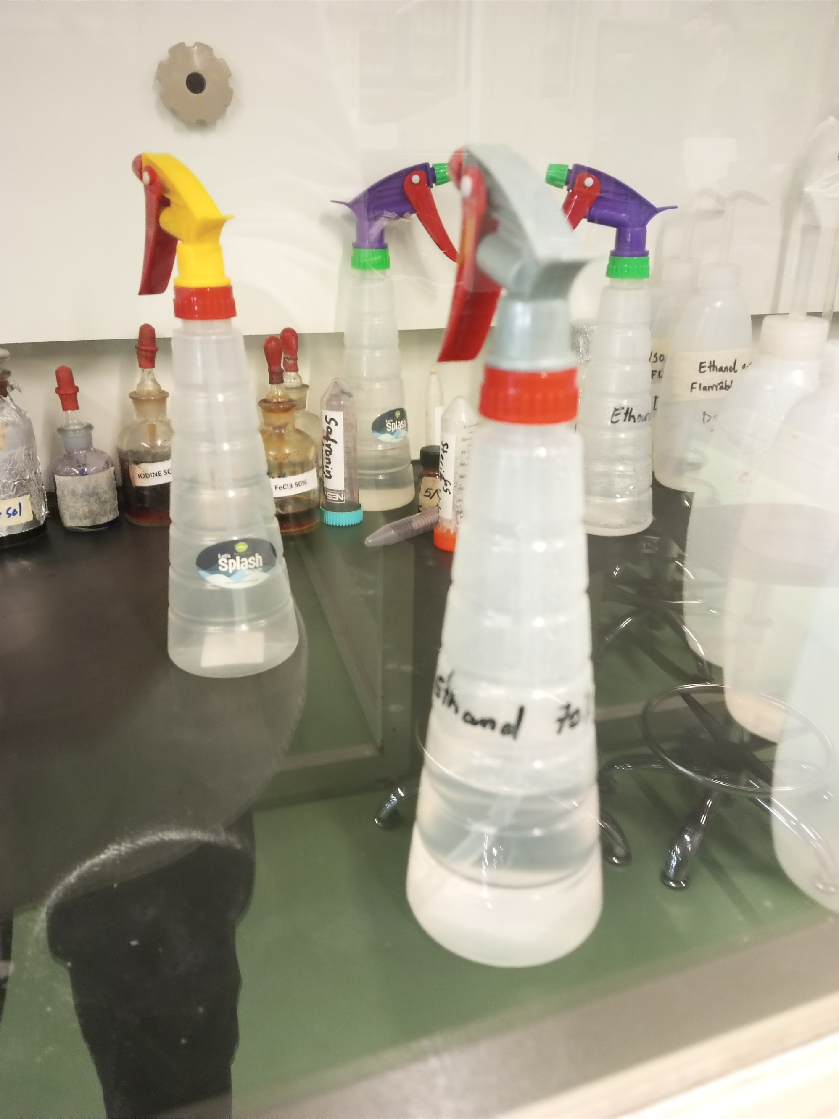

7: 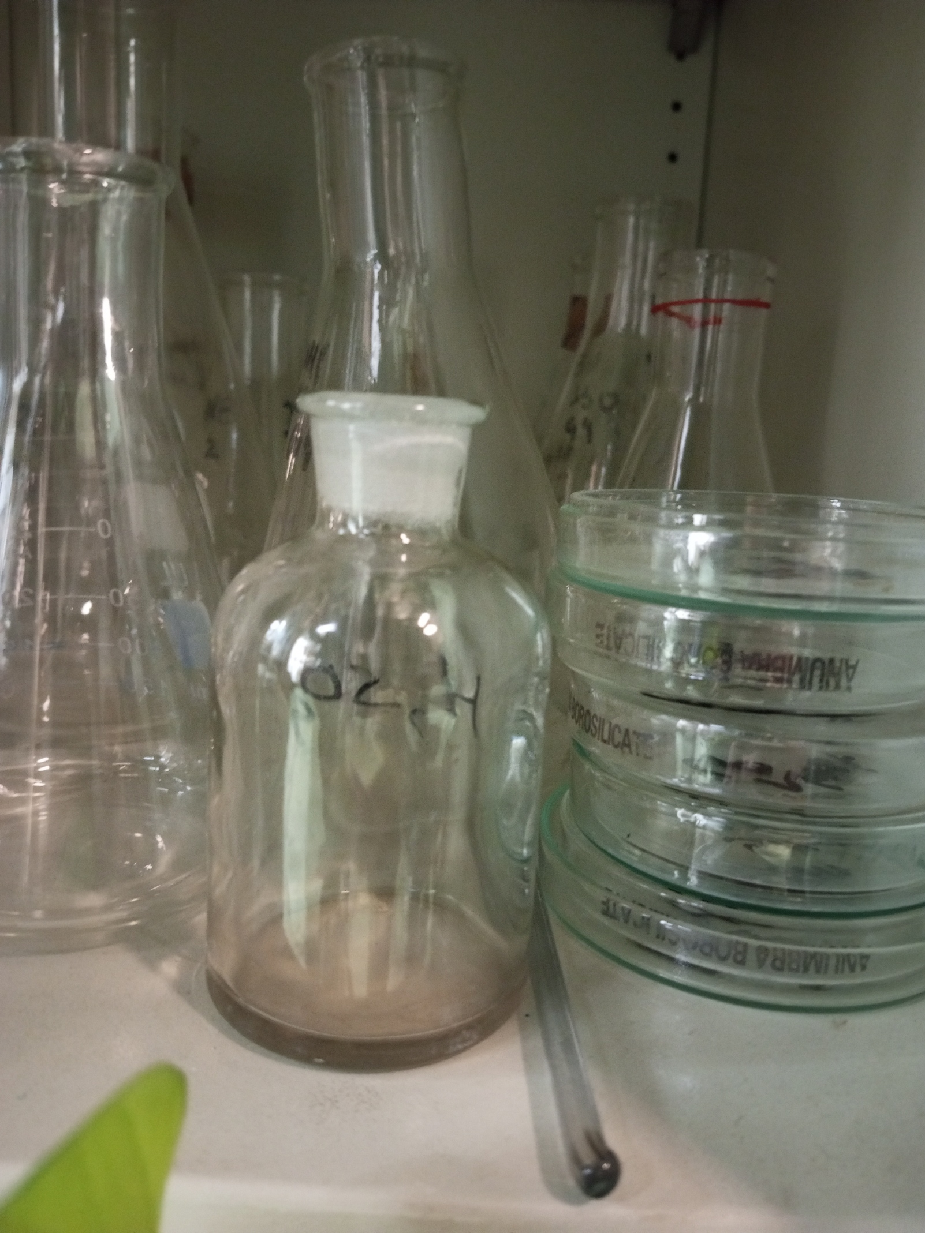
8: 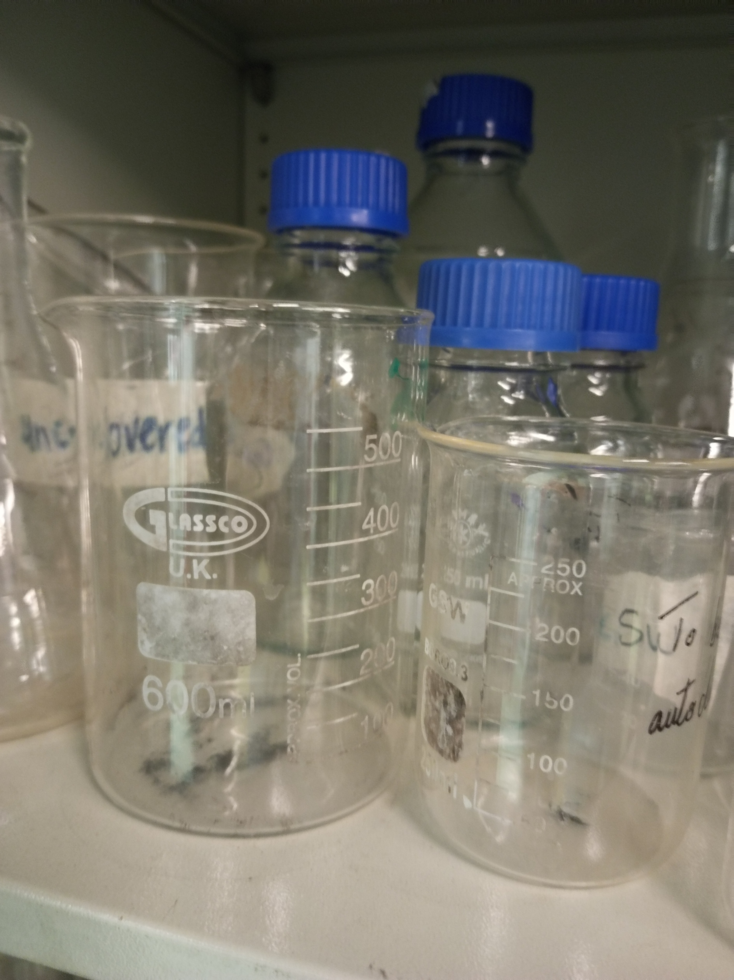

9: 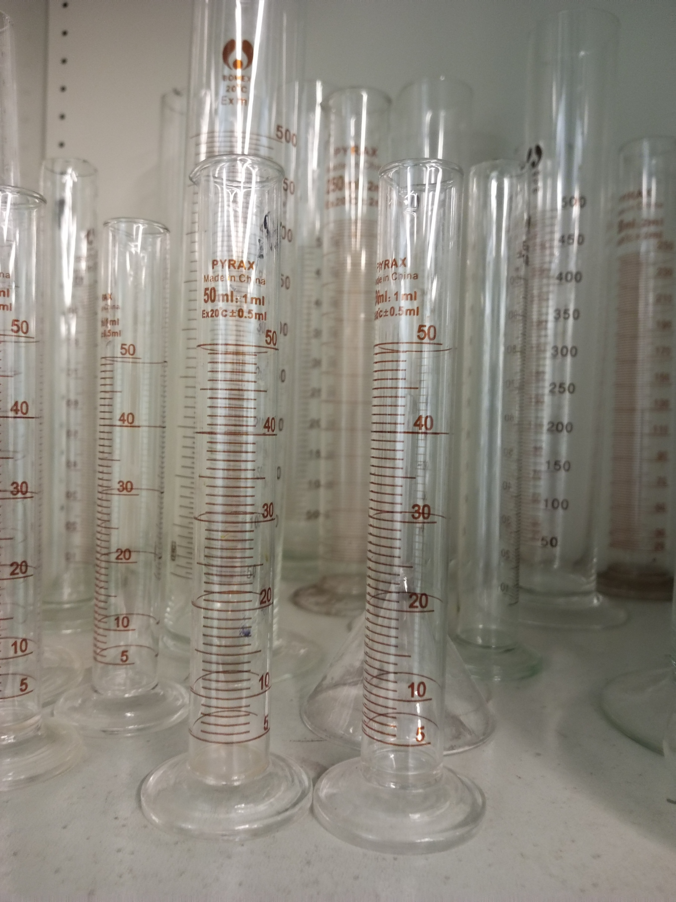
10: 